**All documentation on the Voice Activated Smart Home**

**User Manual**

**General**

This project presents the design of the low cost home automation system using the IoT (Internet of Things) technology along with the feature of Voice recognition. The Internet of things (IoT) is the inter-networking of physical devices, vehicles, buildings, and other items embedded with electronics, software, sensors, actuators, and network connectivity that enable these objects to collect and exchange data. In this project IoT technology is used to control the home appliances wirelessly over the internet. The computing module used is a Raspberry pi development board. The project also aims to provide a speech control interface to the users to control the appliances. Speech recognition is provided using an online Voice-To-Text platform called wit. The home automation system listens for the user’s speech and whenever a defined phrase is identified it triggers corresponding action to switch appliances on or off. With Voice recognition physically challenged people can control appliances with much more ease

The entire system consists of two parts:

**1. Speech recognition**

The speech recognition uses a python script called speechrecognition.py. This python script uses speech recognition library to record and process speech. It uses the wit API online Speech-To-Text platform to convert the speech to text. When the user provides the speech through the microphone the speech gets recorded by the python script in WAV format and is send to the wit platform along with an unique API key provided by the wit account. Once the audio file reaches wit it converts it in to text using their advanced speech recognition algorithm. The text is then send back to the python script. In the python script it is checked with the predefined commands to turn appliances on or off. If the phrase matches with text received then corresponding string (ON or OFF) is written to the file of respective relay. A python script is used called iot.py. It monitors the content of the files for each relays (relay1.txt – relay4.txt). Based on the content of the file ie either “ON” or “OFF” the python scripts turns the GPIO pin high or low for each of the relay connected to it.

**2. Web Interface**

The Raspberry pi hosts the web pages to control devices through an Apache web server. The web pages include index.html, controller.php, button.php, checklogin.php, logout.php. There file defined for each relays containing the string “ON” or “OFF”. The index page acts as the home page. Once user logs in with a username and password the check login page checks the credential with a preset credential. If a match occurs user will be redirected to controller page with after setting a session variable else user will be redirected to login page. In the controller page user can switch device on or off through buttons. On press of each button a button page is invoked which checks the button id and writes appropriate string to the corresponding relay file. A python script is used called iot.py. It monitors the content of the files for each relays (relay1.txt – relay4.txt). Based on the content of the file ie either “ON” or “OFF” the python scripts turns the GPIO pin high or low for each of the relay connected to it. Thus, the relay turns on and off based on user input and any appliance can be connected to it to get controlled via internet.

**Assembly**

The setup of the raspberry pi is very simple. The require materials are as follows:

5 x female to female jumper cables

1 x raspberry-pi

1 x 4 Channel Relay

1 x micro-USB cable

1 x power supply

**Hardware Connection:**

The hardware connection is pretty straight forward:

Connect the relay module to Raspberry pi to 5v and GND pins as marked on relay module. Connect the signal pins of module to GPIO header 5,7,11,13 respectively.

Now, tap wires from each switches of power strip and connect it to Normally Open terminals of each relay. Power the raspberry pi using a 5v micro USB adapter and also connect the power strip to Wall socket. See below pictures for detail information.

**Schematic of Raspberry Pi connected to 4 Channel Relay Module**

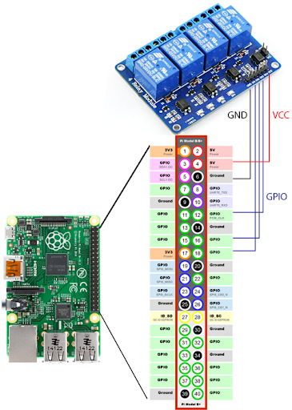

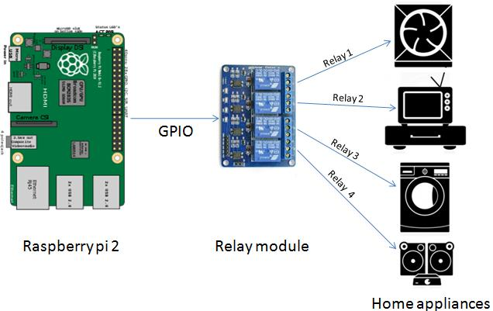

**Diagram of How Voice Activated Home Automation works:**

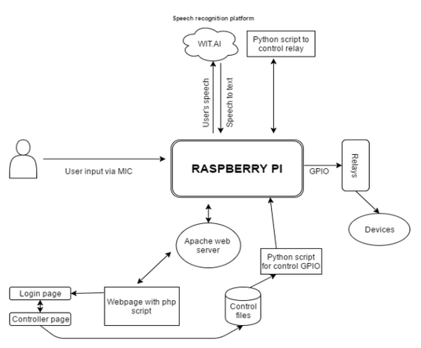

**Controlling the Devices:**

To control the device from web interface, follow the steps:

If you provide voice command like "Kitchen On" then relay connected to gpio 5 will turn on and "Kitchen off" for switching off.

For providing more command you can simply edit the python script to add you own command

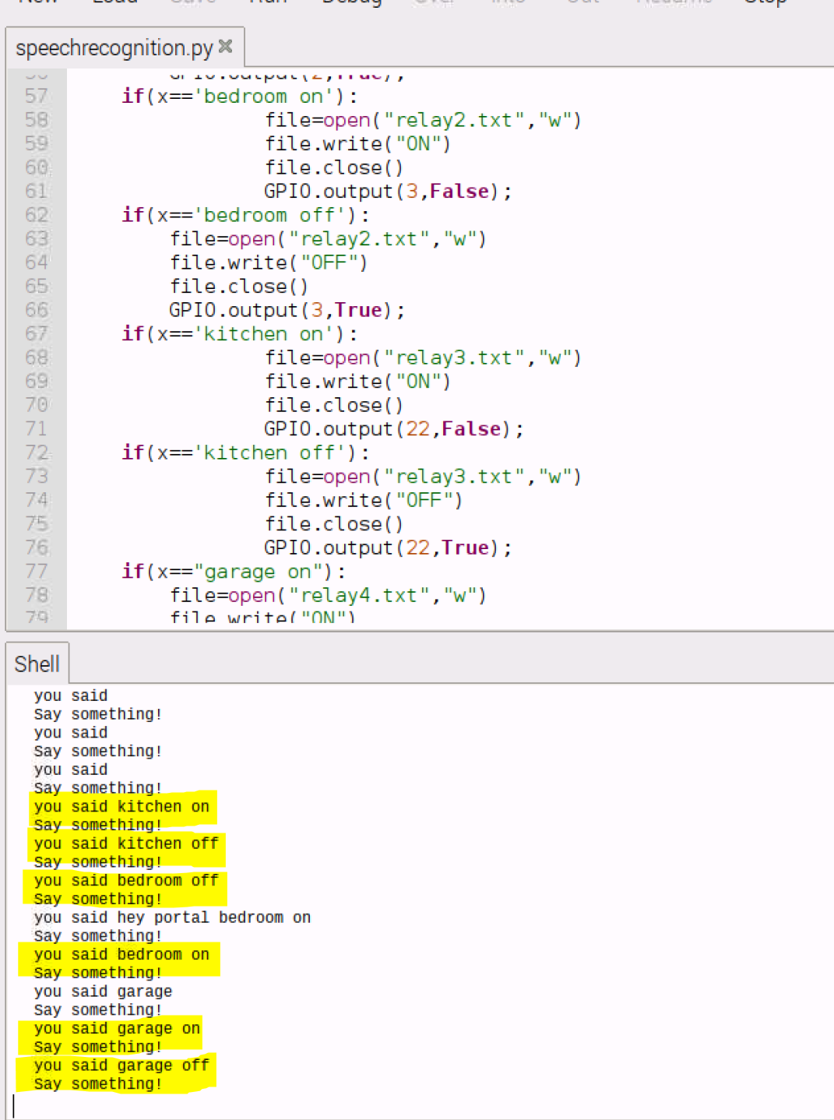

To control the device from web interface, follow the steps:

1. Go to the IP address on a local device on same network, you will get the home page
2. Enter the username: admin and password: smarthome
3. You will get a controller page to switch device on and off along with current status of device

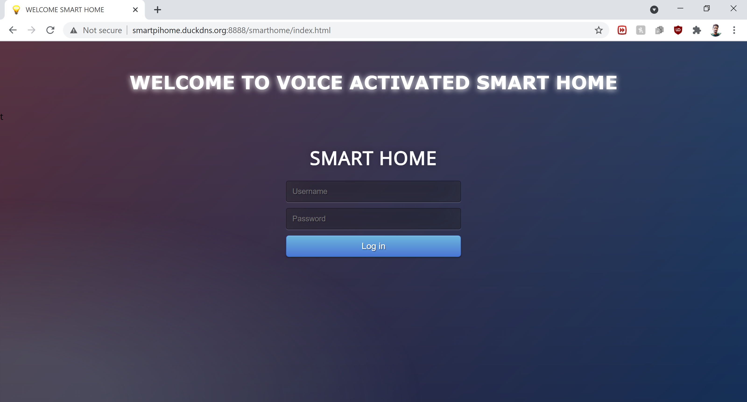

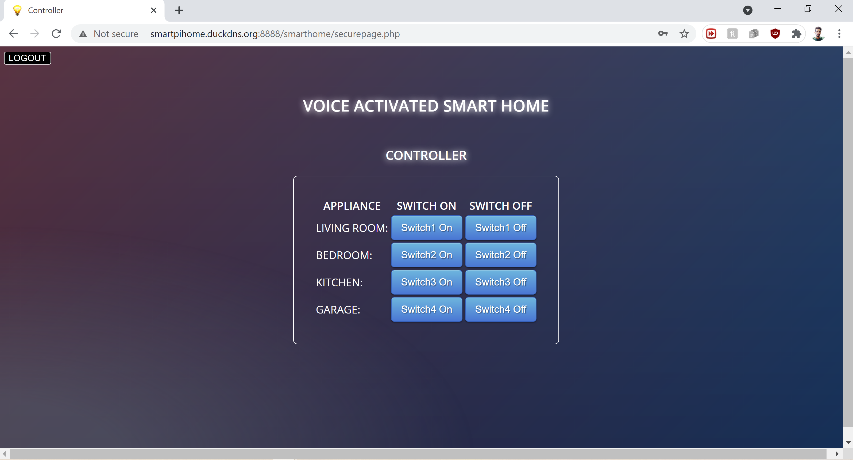

**The readout on the raspberry pi of when a Voice command is given**



That's it. NOW YOU HAVE A SMART HOME AUTOMATION SYSTEM INSTALLED ON YOUR HOME.